**R Programming**

**All About R and R Studio Download and Installation**

R is a programming language.

To use R on our system, we have to install R.

For R: <https://cran.r-project.org/bin/windows/base/>

For R Studio: <https://www.rstudio.com/products/rstudio/download/> 🡪 choose “**RStudio Desktop**”

------------------------------------------------------------------------------------------------------------------------------------

When we will install R and R Studio, then we have to open R Studio IDE to write the R codes.

The R Studio interface will look like this:

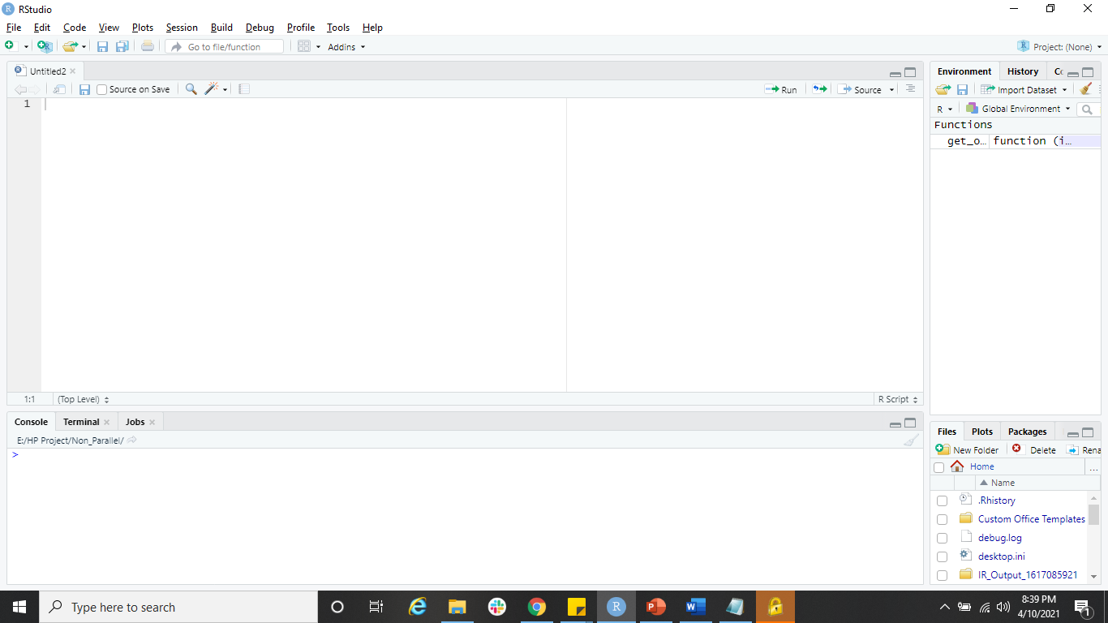

To write the codes in R Studio follow below steps:

Click “File” 🡪 “New File” 🡪 “R Script”

Then we will get a blank space to write the codes. This is the **Editor window**.

**Console Window:** This will show us the logs.

**Global Environment Window:** Here, what ever tables and datasets which we have created, that we will get here.

- “**c**” is a function in R which means **Combine**.

When we have to pass multiple values, we will use this function in R.

- If we want to create a dataset/dataframe then we have to use the function “**data.frame**”.

**Ex:** ex1 = data.frame(

Name = c("a","b","c","d"),

Salary = c(1000,2000,3000,4000),

Designation = c("e","f","g","h")

)

ex1

- If we want to check the datatype of the variables, then we will use the function called **str()**. This function will give me a summary type of structure.

**Ex:** str(ex1)

- Another function i.e. “**Class**”

This tells us whether it is a dataframe or Matrix or list, etc.

**Ex:** class(ex2)

- Import the dataset

ex2 = read.csv("E:\\PGPBA - BI\\Training\\R\\Final\\Data\\Data.csv")

OR

ex2 = read.csv("E:/PGPBA - BI/Training/R/Final/Data/Data.csv")

ex2

- Check top sample data

Ex: head(ex2)

OR

head(ex2,n=10) [to check specific range of data]

- Check bottom sample data

Ex: tail(ex2)

OR

tail(ex2,n=10) [to check specific range of data]

- To clear the console the shortcut is “**ctrl+L**”.